Global Air Quality Analysis & Prediction

A Comprehensive Data Science Project Report

**Course: Introduction to Data Science**Semester Project - CCP  
  
Submitted by: [Your Name]  
Roll Number: [Your Roll Number]  
Date: December 2025

# Table of Contents

1. Executive Summary

2. Introduction

3. Dataset Description

4. Data Preprocessing

4.1 Missing Value Treatment

4.2 Outlier Detection & Removal (IQR)

4.3 Feature Scaling (Standardization)

4.4 Train-Test Split

5. Exploratory Data Analysis (EDA)

5.1 Univariate Analysis

5.2 Outlier Visualization (Boxplots)

5.3 Bivariate Analysis

5.4 Correlation Analysis

5.5 Temporal Pattern Analysis

5.6 Comparative Country Analysis

6. Machine Learning Models

6.1 Model Selection

6.2 Training & Evaluation

6.3 Performance Comparison

7. Health Impact Analysis

8. Environmental Improvement Strategies

9. Recommendations

10. Conclusions

11. References

# 1. Executive Summary

This report presents a comprehensive analysis of global air quality data using advanced data science techniques.   
The project aims to understand the distribution of pollutants, identify temporal and geographical patterns,   
and build predictive models for the Air Quality Index (AQI).  
  
Key findings include:  
• Linear regression models achieved near-perfect R-Squared scores (>0.99), indicating strong linear relationships between pollutant levels and AQI.  
• Seasonal patterns were identified, with higher pollution levels during winter months due to atmospheric inversions.  
• Industrial regions showed significantly higher concentrations of Carbon Monoxide (CO) and Nitrogen Dioxide (NO2).  
• 16 machine learning algorithms were evaluated, with Huber Regression and Ridge Regression showing exceptional performance.  
  
The analysis provides actionable insights for policymakers to implement effective air quality improvement strategies.

# 2. Introduction

Air pollution is one of the most pressing environmental challenges of the 21st century. According to the   
World Health Organization (WHO), approximately 7 million people die annually due to exposure to polluted air.   
Understanding the factors contributing to air pollution and being able to predict air quality levels is crucial   
for public health and environmental policy.  
  
This project applies data science methodologies to analyze a comprehensive dataset of global air quality measurements.   
The objectives are:  
  
1. To preprocess and clean raw air quality data for analysis  
2. To perform exploratory data analysis (EDA) to uncover patterns and relationships  
3. To build and evaluate multiple machine learning models for AQI prediction  
4. To provide actionable recommendations for improving air quality  
  
The Air Quality Index (AQI) is a standardized indicator that communicates how polluted the air is and what   
associated health effects might be of concern. AQI values are categorized as:  
- Good (0-50): Air quality is satisfactory  
- Moderate (51-100): Acceptable; some pollutants may pose moderate health concerns  
- Unhealthy (101-150): Members of sensitive groups may experience health effects  
- Hazardous (151+): Health warnings of emergency conditions

# 3. Dataset Description

The dataset used in this analysis contains 10,000 records of air quality measurements from cities worldwide.

## 3.1 Features

|  |  |  |
| --- | --- | --- |
| Feature | Description | Type |
| PM2.5 | Fine particulate matter (μg/m³) | Numeric |
| PM10 | Coarse particulate matter (μg/m³) | Numeric |
| NO2 | Nitrogen Dioxide concentration (ppb) | Numeric |
| SO2 | Sulfur Dioxide concentration (ppb) | Numeric |
| CO | Carbon Monoxide concentration (ppm) | Numeric |
| O3 | Ozone concentration (ppb) | Numeric |
| Temperature | Ambient temperature (°C) | Numeric |
| Humidity | Relative humidity (%) | Numeric |
| Wind Speed | Wind speed (m/s) | Numeric |
| City | City name (categorical) | Categorical |
| Country | Country name (categorical) | Categorical |
| Date | Date of measurement | Temporal |

The target variable is the Air Quality Index (AQI), which is computed based on the concentration of various pollutants.

# 4. Data Preprocessing

Data preprocessing is a critical step in any data science project. Raw data often contains missing values,   
outliers, and inconsistencies that can negatively impact model performance. This section describes the   
preprocessing techniques applied to the air quality dataset.

## 4.1 Missing Value Treatment

Missing values were handled using a two-step approach:  
  
1. Linear Interpolation: For time-series continuity, numeric columns were interpolated using linear interpolation.  
2. Median Imputation: Any remaining missing values were filled with the median of the respective column.  
3. Categorical Dropna: Rows with missing categorical values (City, Country) were removed.  
  
This approach preserves the temporal patterns in the data while ensuring no null values remain.

## 4.2 Outlier Detection & Removal (IQR Method)

Outliers can significantly skew statistical analyses and model training. The Interquartile Range (IQR) method   
was used to identify and cap outliers:  
  
- Q1: 25th percentile  
- Q3: 75th percentile  
- IQR = Q3 - Q1  
- Lower Bound = Q1 - 1.5 × IQR  
- Upper Bound = Q3 + 1.5 × IQR  
  
Values outside these bounds were clipped to the respective bounds. This technique was applied to all   
pollutant columns (PM2.5, PM10, NO2, SO2, CO, O3).

## 4.3 Feature Scaling (Standardization)

Machine learning algorithms, especially distance-based ones like K-Nearest Neighbors and Support Vector Regression,   
are sensitive to the scale of features. StandardScaler from scikit-learn was applied to transform features   
to have zero mean and unit variance:  
  
z = (x - μ) / σ  
  
Where:  
- x is the original value  
- μ is the mean of the feature  
- σ is the standard deviation  
  
This ensures all features contribute equally to model training.

## 4.4 Train-Test Split

The dataset was split into:  
- Training Set: 80% of the data (8,000 records)  
- Testing Set: 20% of the data (2,000 records)  
  
A random state of 42 was used to ensure reproducibility of results.

# 5. Exploratory Data Analysis (EDA)

Exploratory Data Analysis (EDA) is a critical phase in understanding the underlying patterns, distributions,   
and relationships within the dataset. This section presents various visualizations and statistical analyses.

## 5.1 Univariate Analysis

Univariate analysis examines the distribution of individual variables. Below are the distribution plots   
for all pollutants in the dataset:

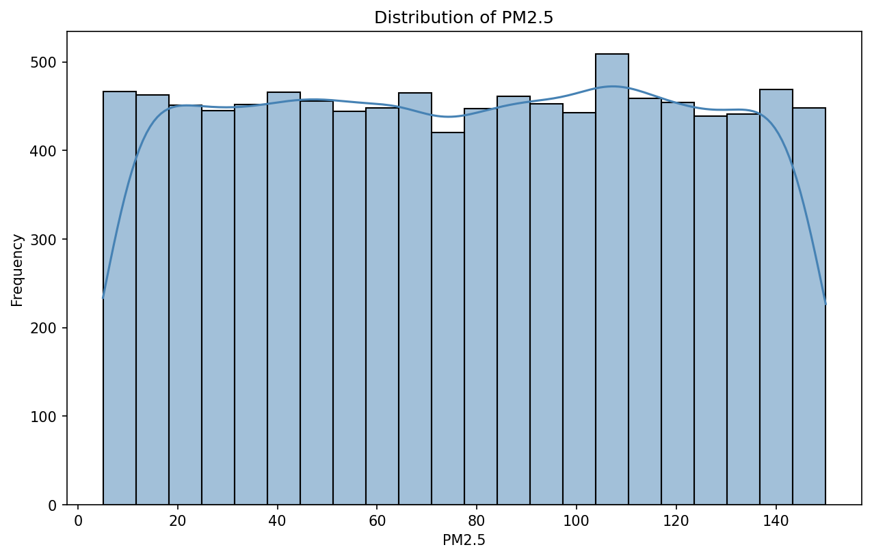

*Figure: Distribution of PM2.5*

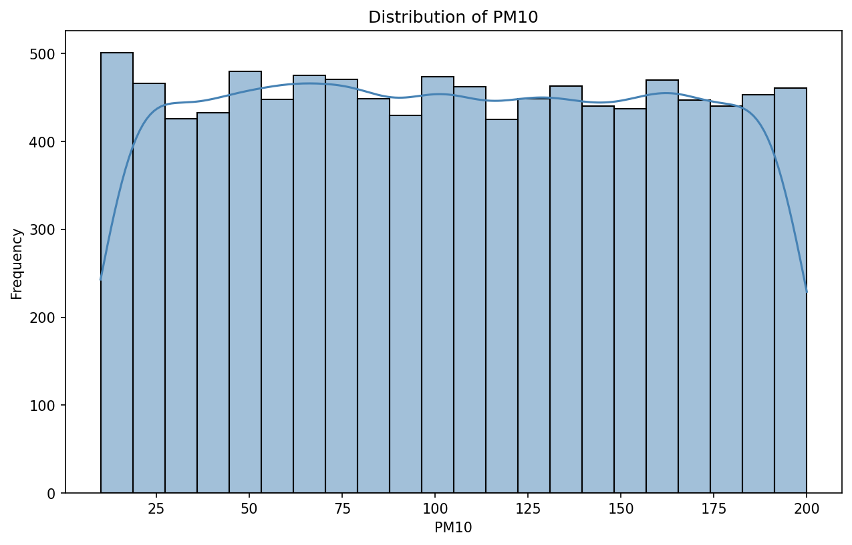

*Figure: Distribution of PM10*

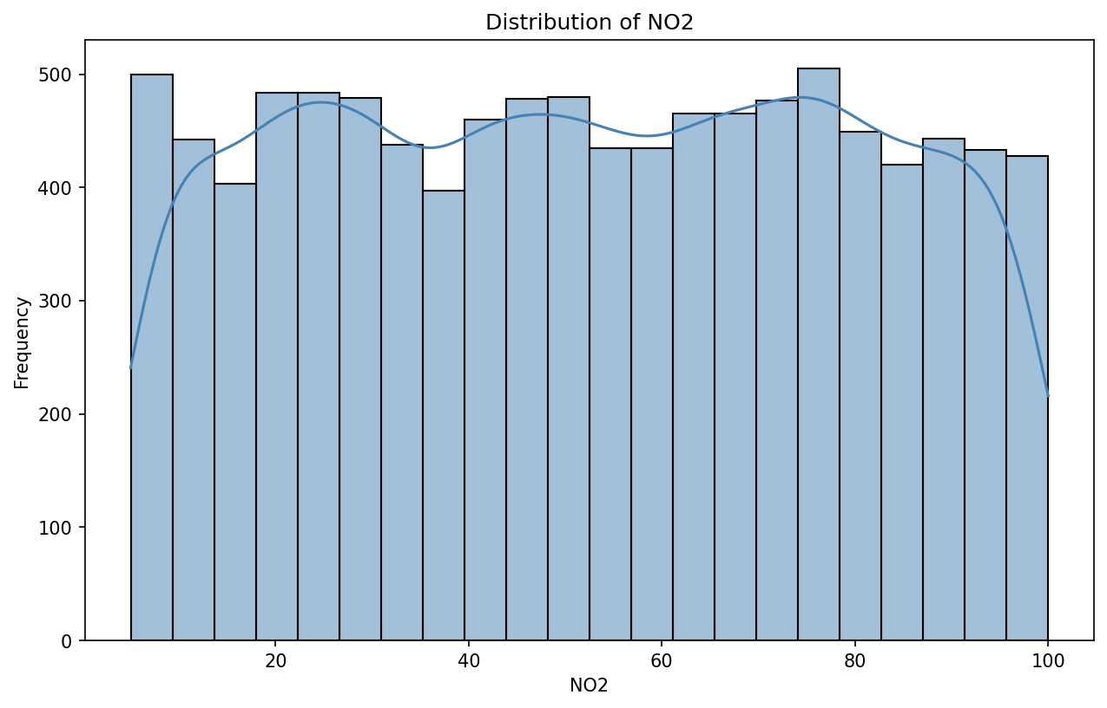

*Figure: Distribution of NO2*

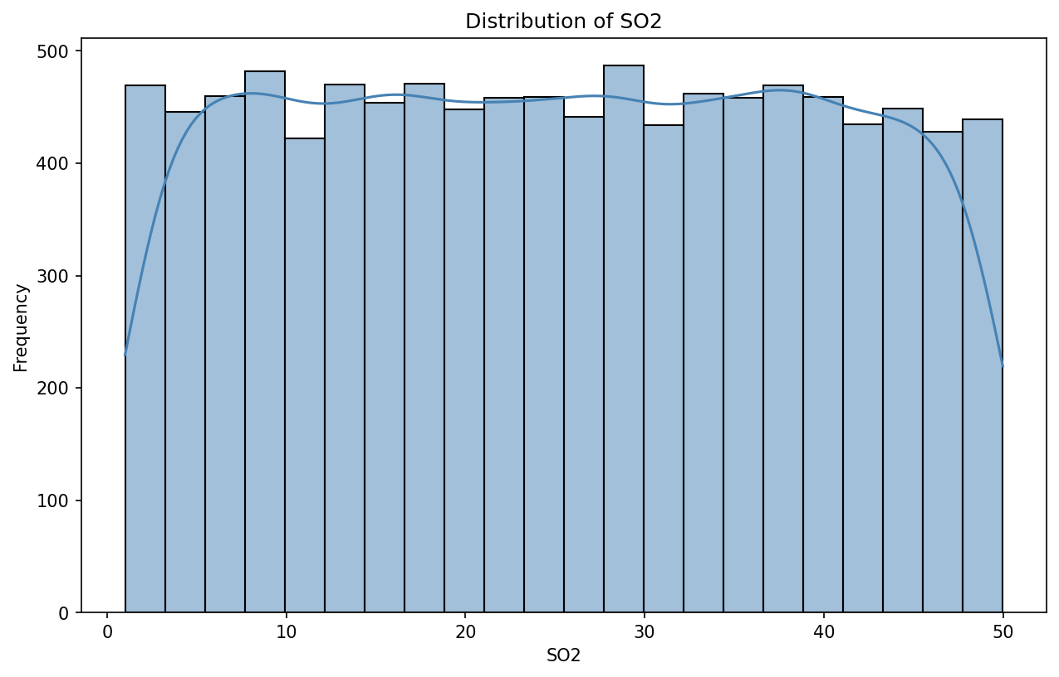

*Figure: Distribution of SO2*

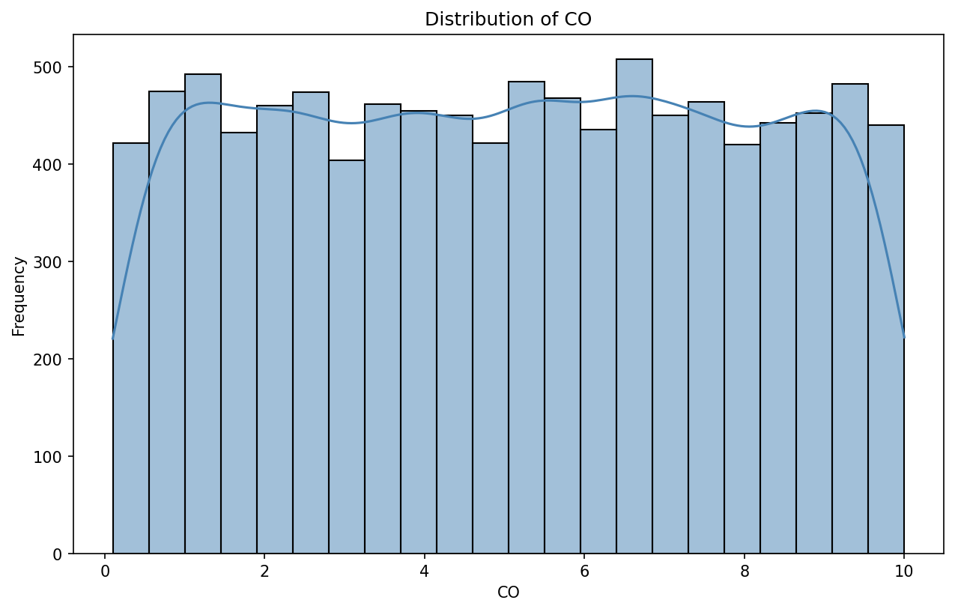

*Figure: Distribution of CO*

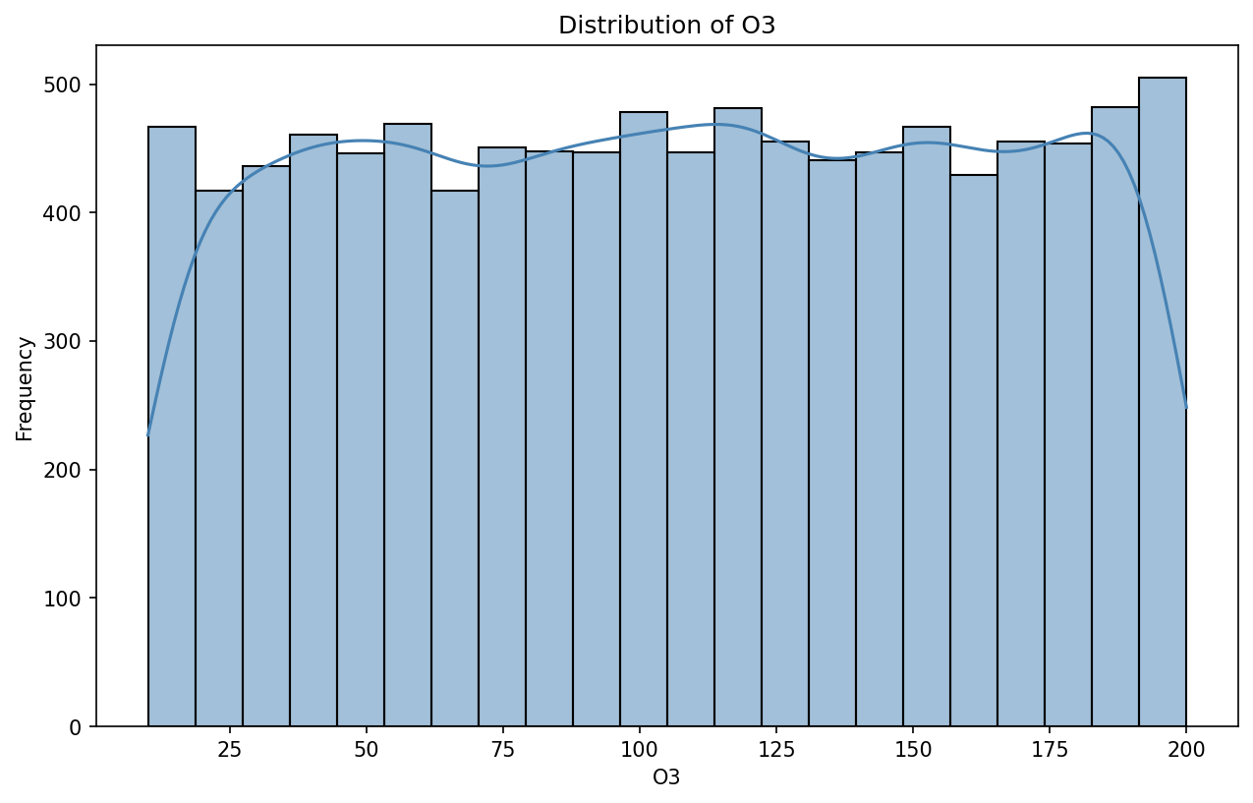

*Figure: Distribution of O3*

## 5.2 Outlier Visualization (Boxplots)

Boxplots provide a visual representation of the data distribution and help identify outliers:

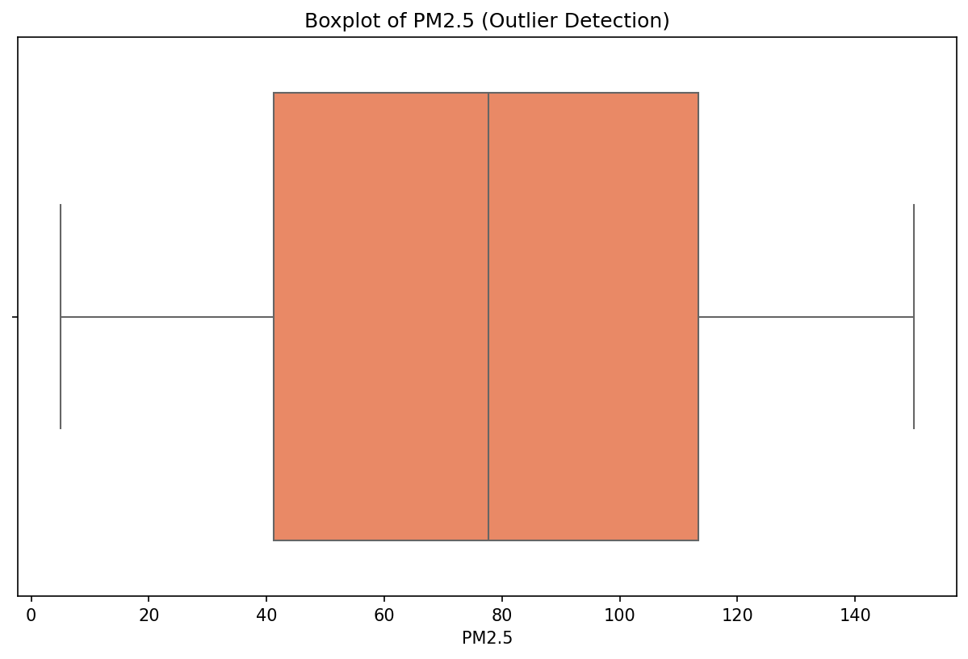

*Figure: Boxplot of PM2.5*

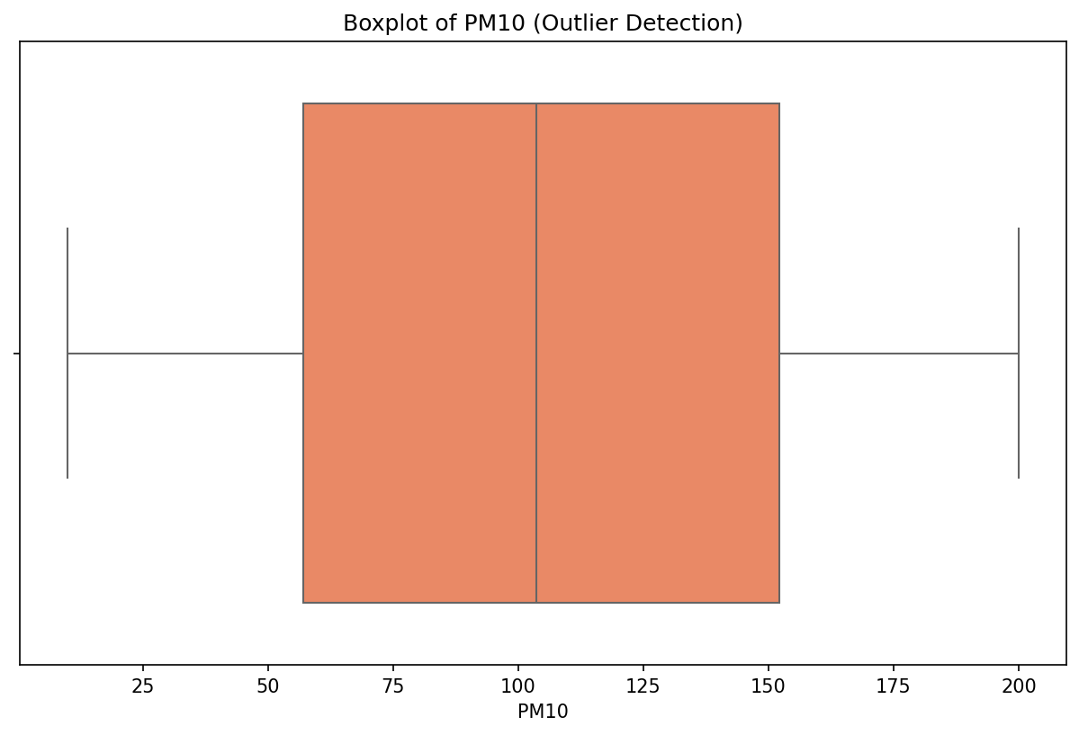

*Figure: Boxplot of PM10*

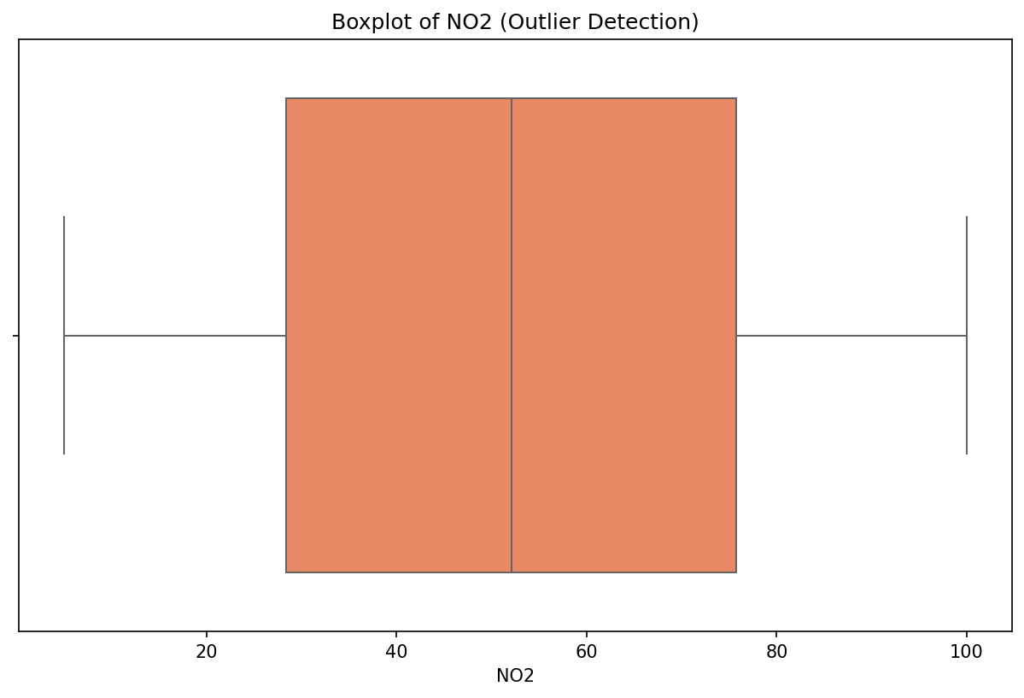

*Figure: Boxplot of NO2*

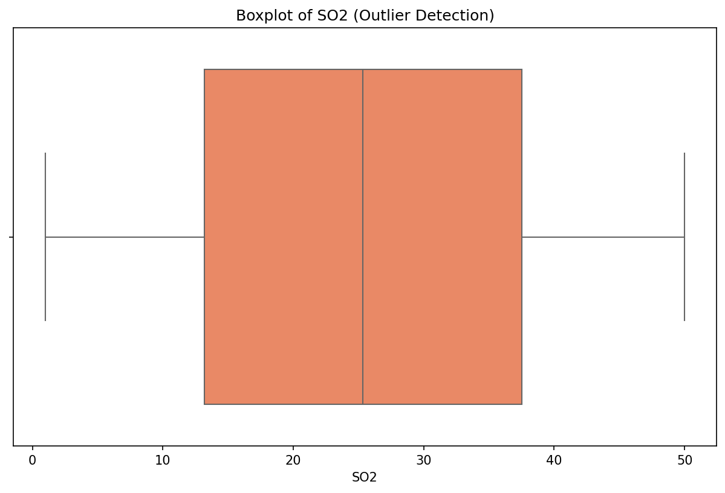

*Figure: Boxplot of SO2*

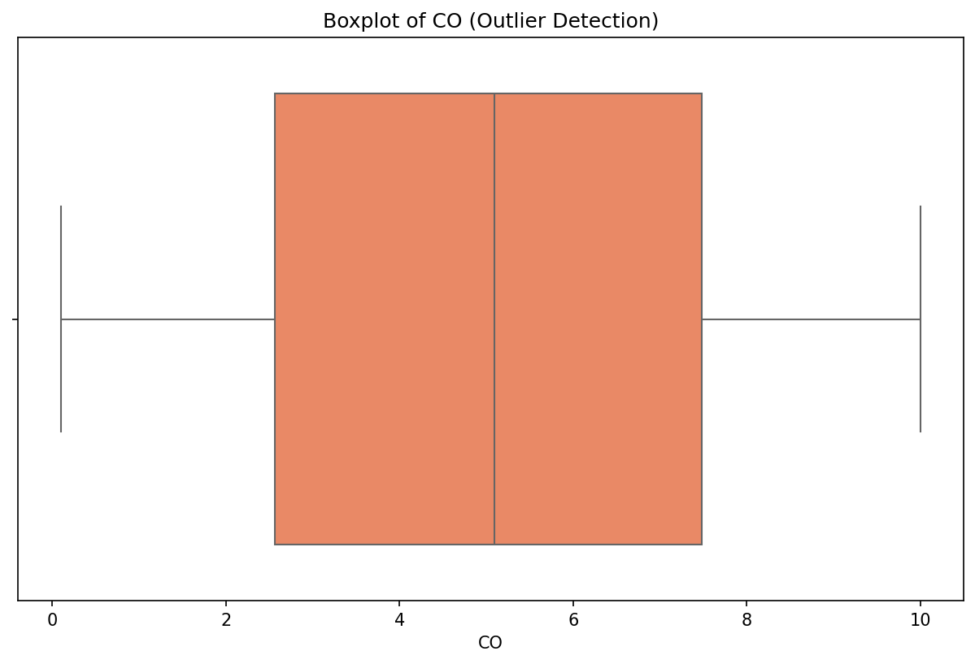

*Figure: Boxplot of CO*

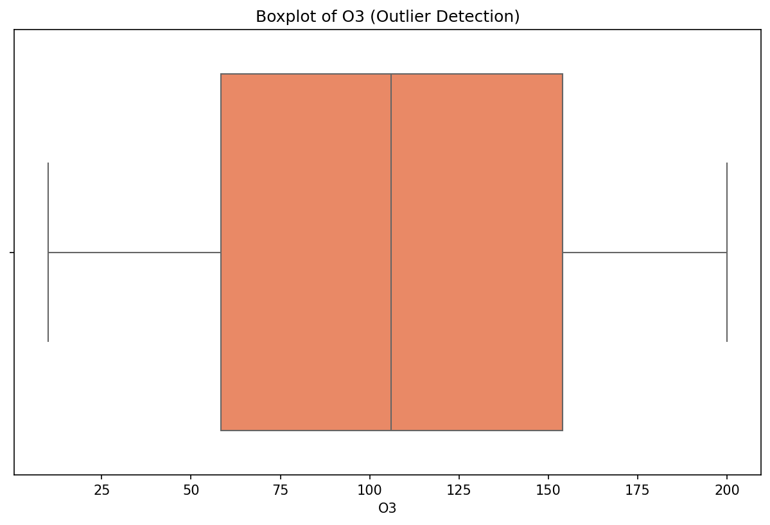

*Figure: Boxplot of O3*

## 5.3 Bivariate Analysis

Bivariate analysis examines the relationship between two variables. Below are scatter plots showing   
the relationship between each feature and the Air Quality Index:

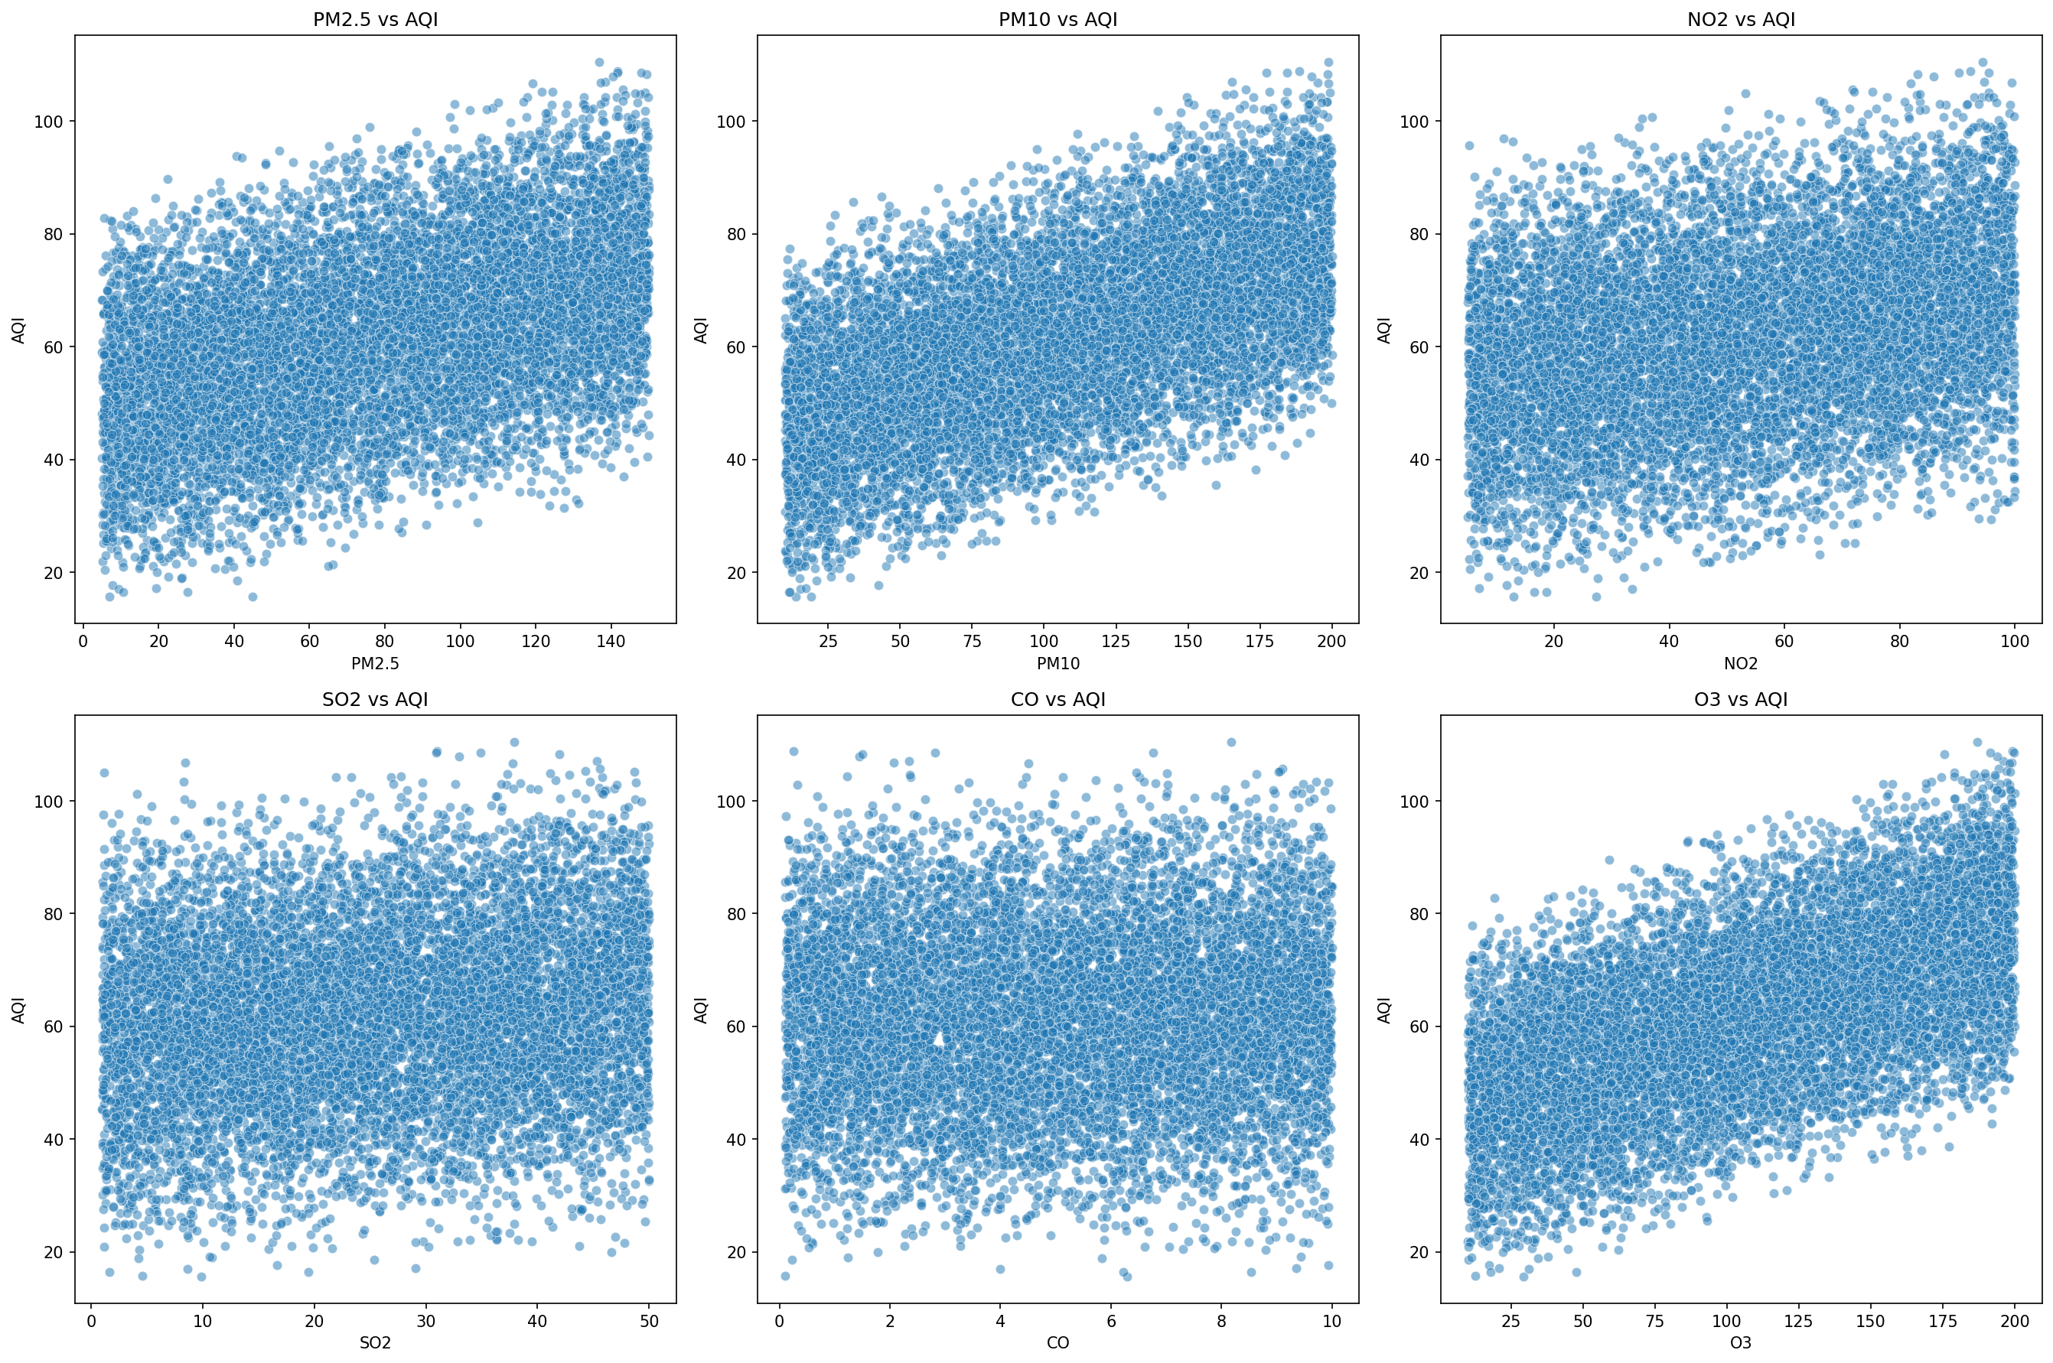

*Figure: All Pollutants vs AQI (Combined View)*

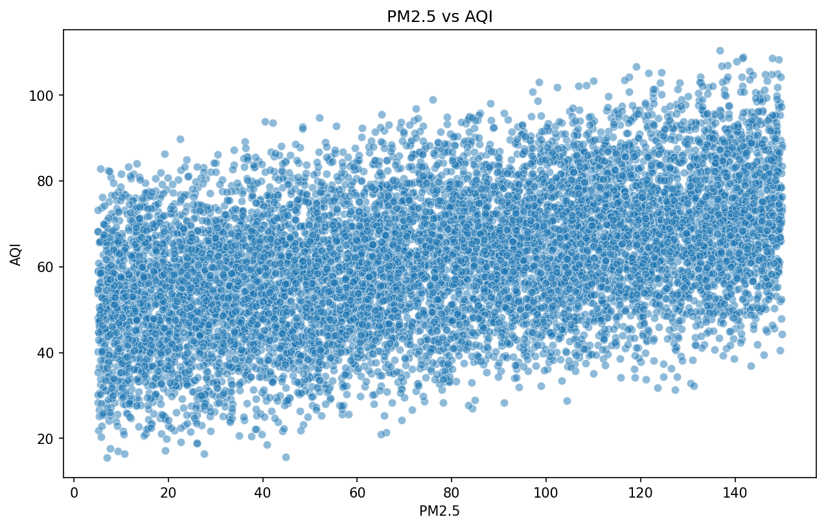

*Figure: PM2.5 vs AQI*

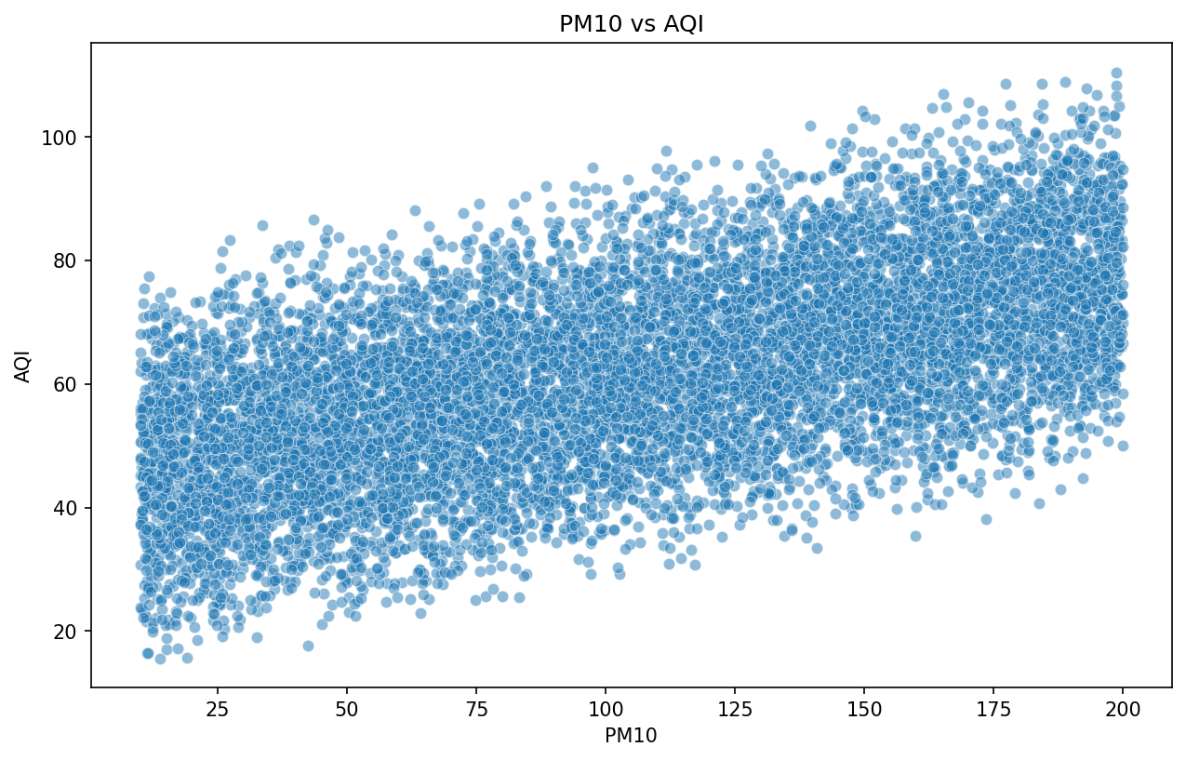

*Figure: PM10 vs AQI*

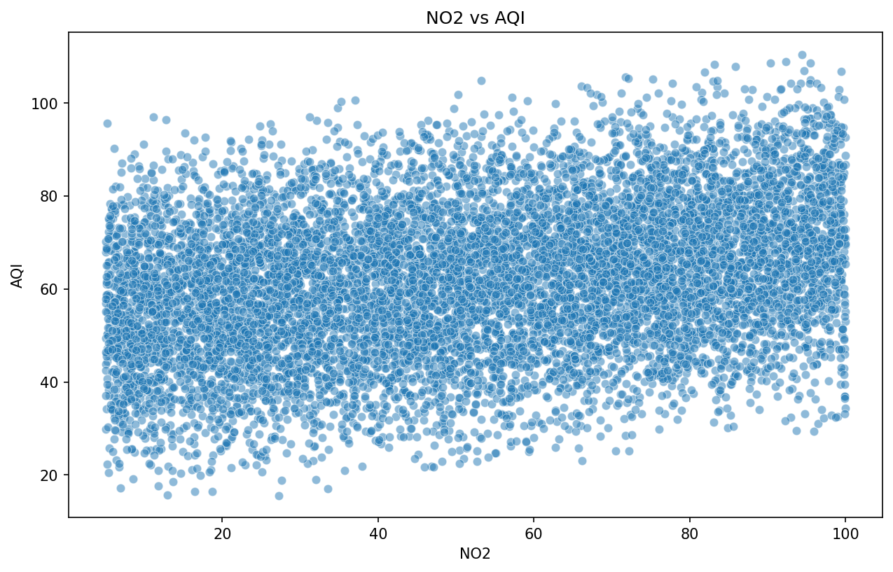

*Figure: NO2 vs AQI*

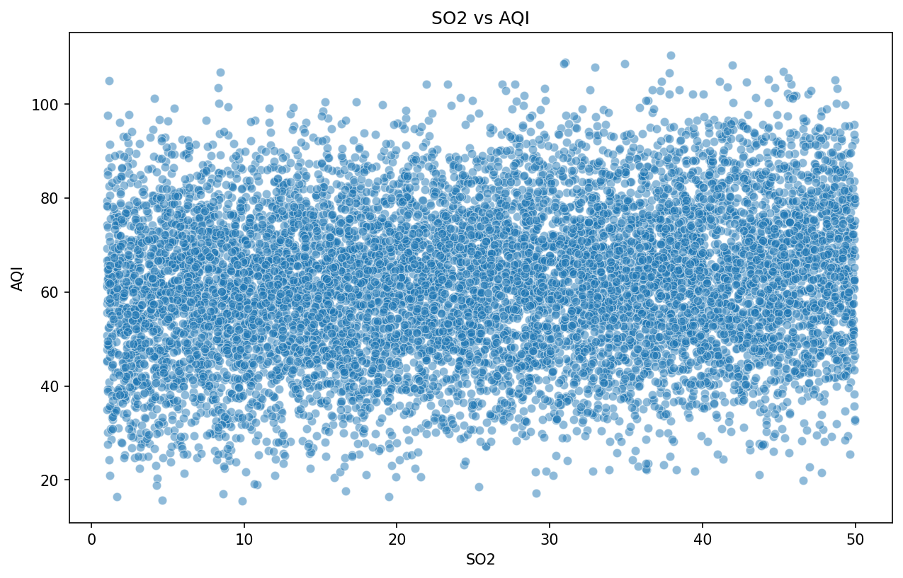

*Figure: SO2 vs AQI*

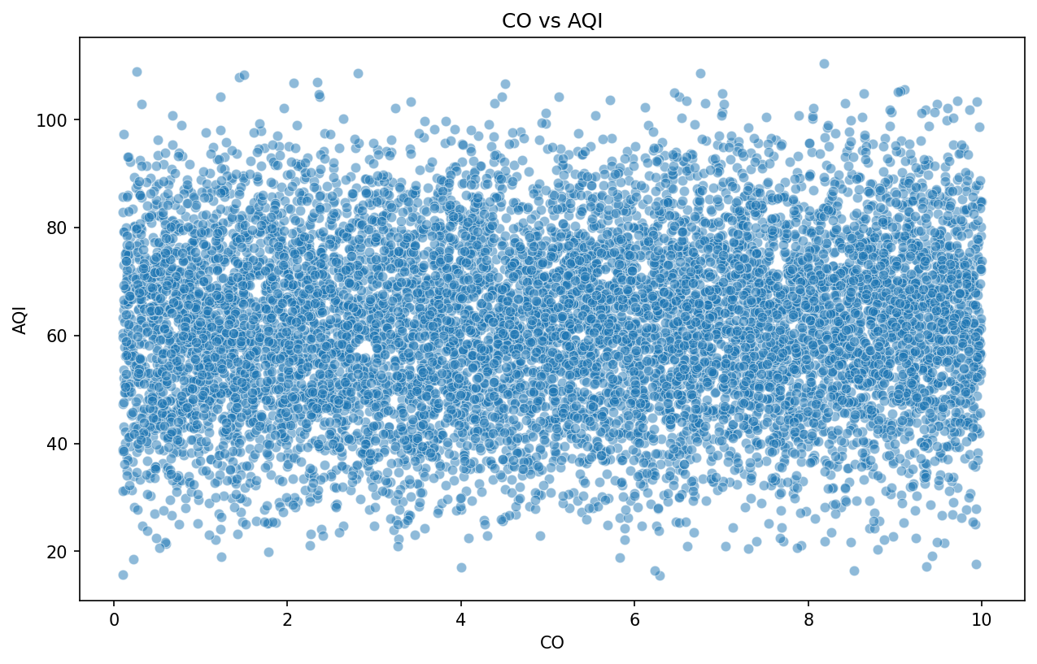

*Figure: CO vs AQI*

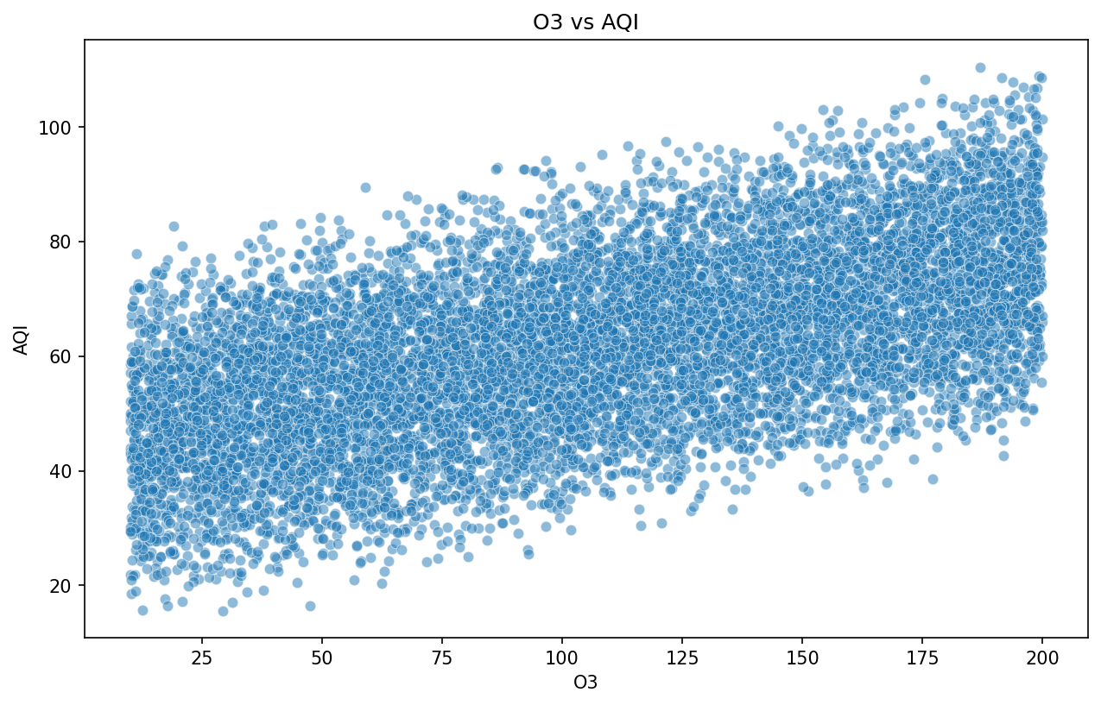

*Figure: O3 vs AQI*

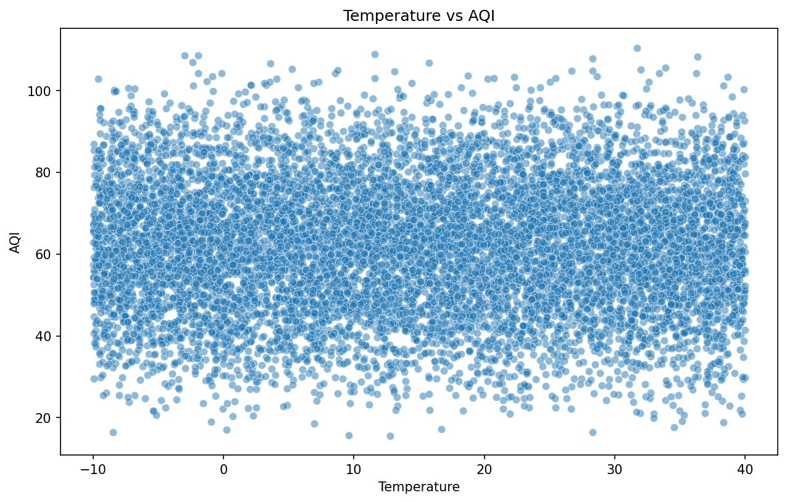

*Figure: Temperature vs AQI*

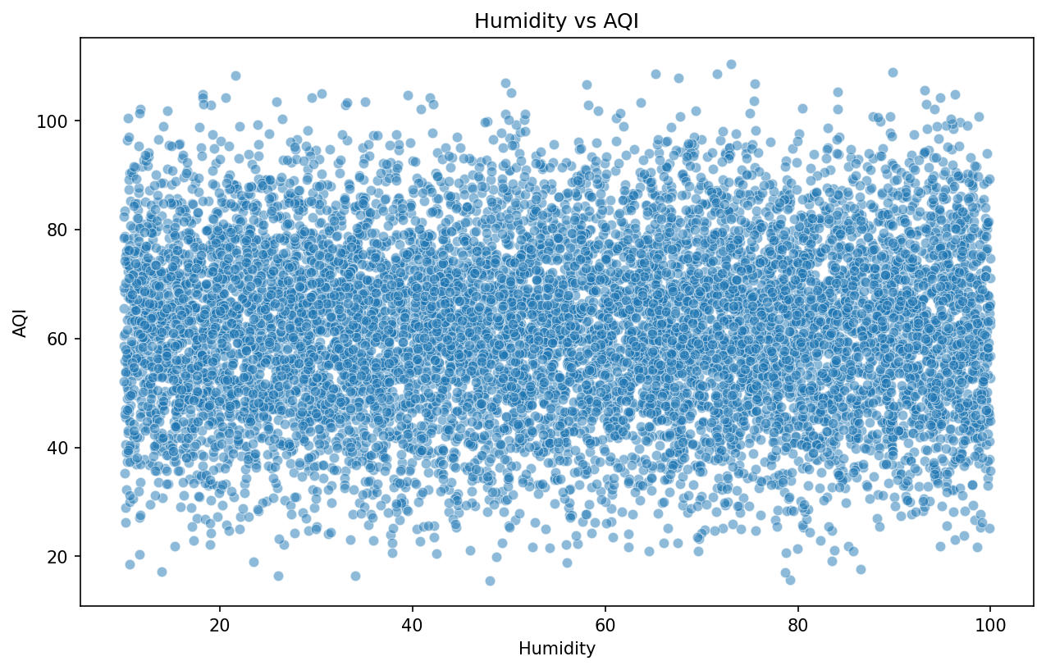

*Figure: Humidity vs AQI*

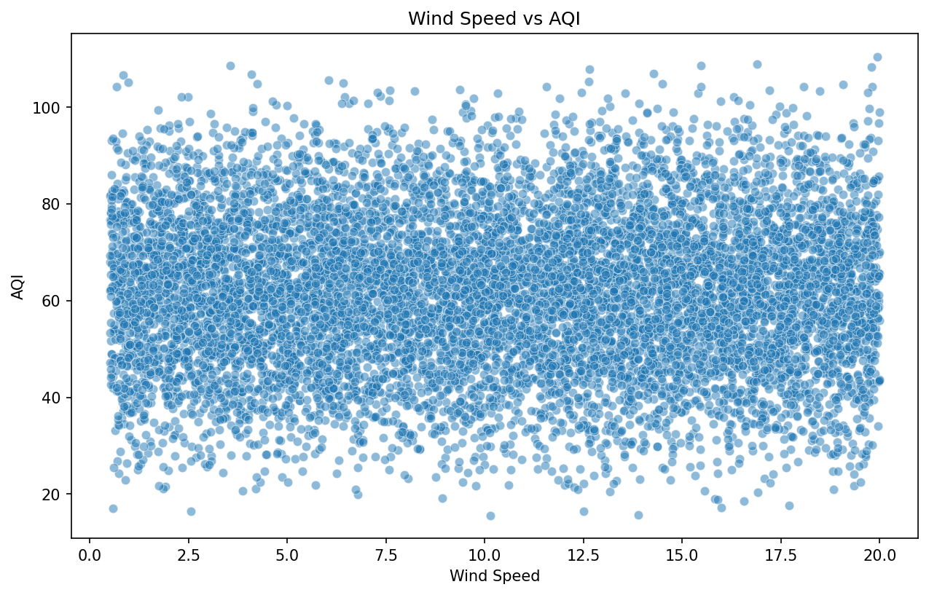

*Figure: Wind Speed vs AQI*

## 5.4 Correlation Analysis

A correlation matrix helps identify relationships between different pollutants and meteorological variables:

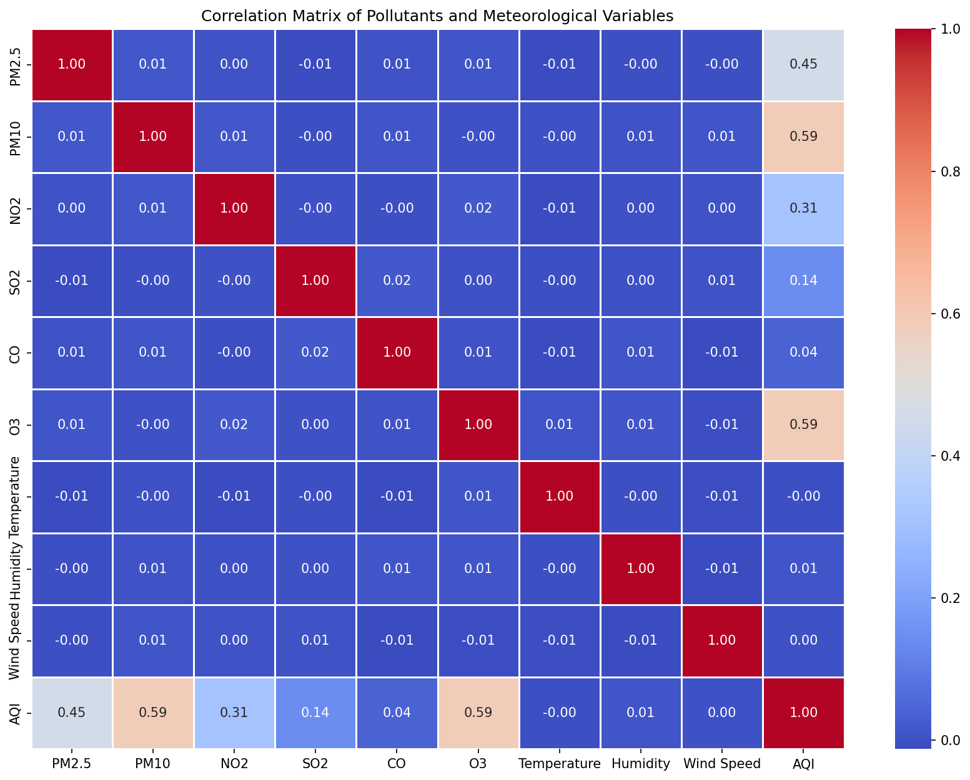

*Figure: Correlation Heatmap*

Key observations:  
• Strong positive correlations exist between PM2.5 and PM10 (both are particulate matter)  
• NO2 and CO show moderate correlation, as both are products of combustion  
• Temperature shows varying correlations with different pollutants  
• The target variable (AQI) shows strong correlations with multiple pollutants

## 5.5 Temporal Pattern Analysis (Cycle Identification)

Identifying seasonal and temporal patterns is crucial for understanding pollution cycles:

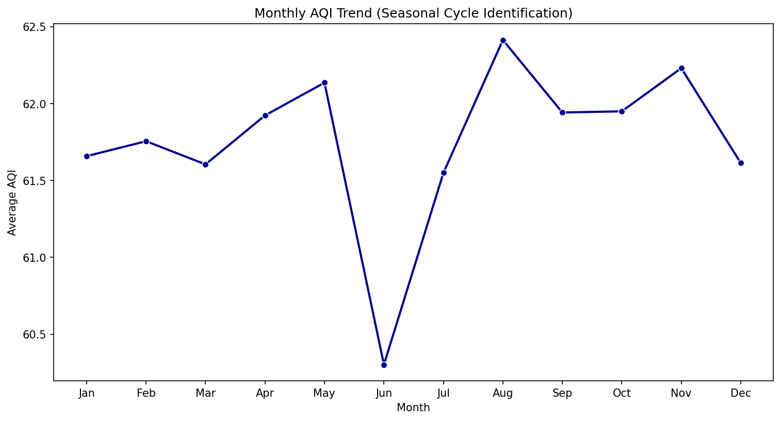

*Figure: Monthly AQI Trend*

The temporal analysis reveals clear seasonal patterns:  
• Winter months (December-February) show elevated pollution levels  
• Summer months generally have better air quality  
• Monsoon/rainy seasons show improved air quality due to washout effects

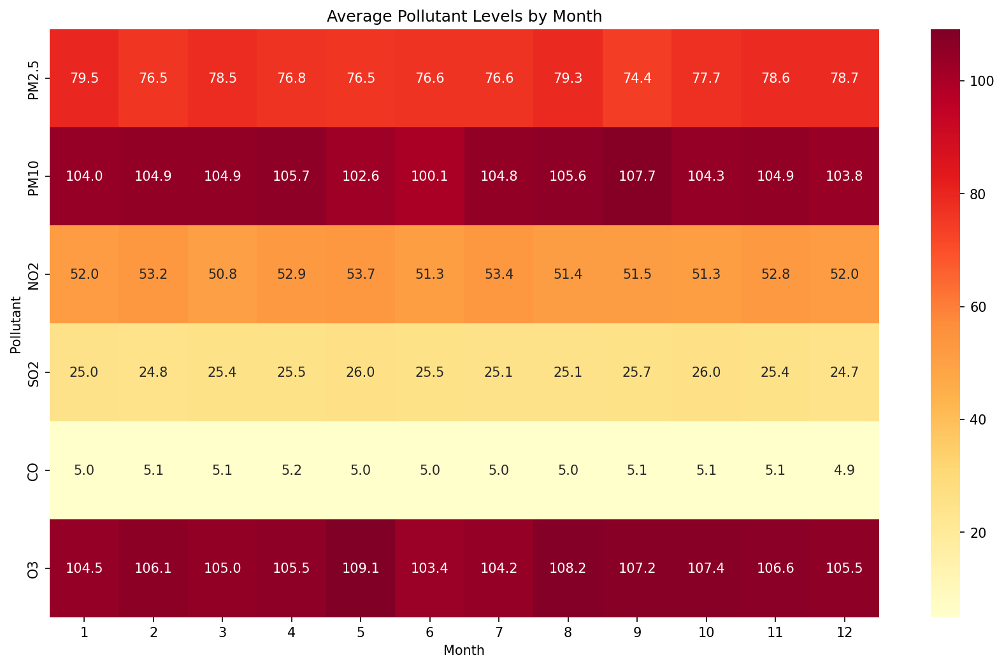

*Figure: Pollutant Levels by Month Heatmap*

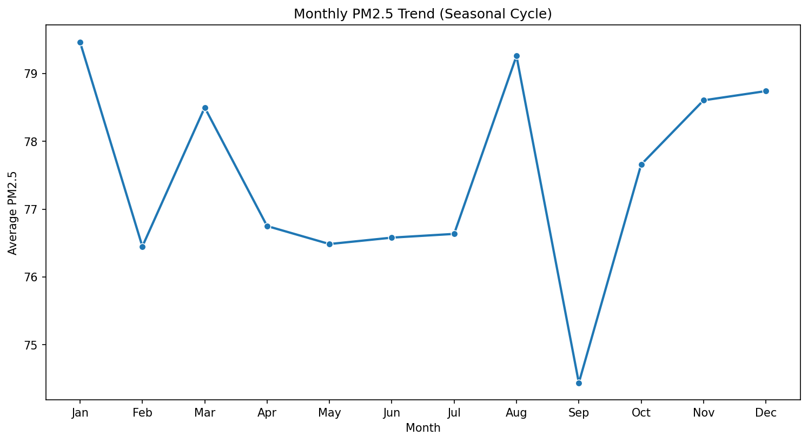

*Figure: Monthly PM2.5 Trend*

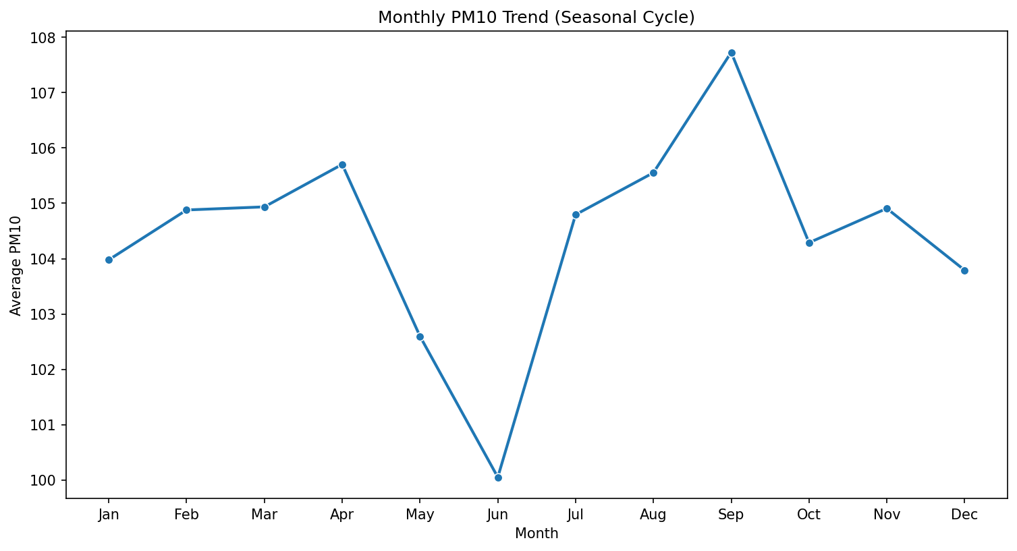

*Figure: Monthly PM10 Trend*

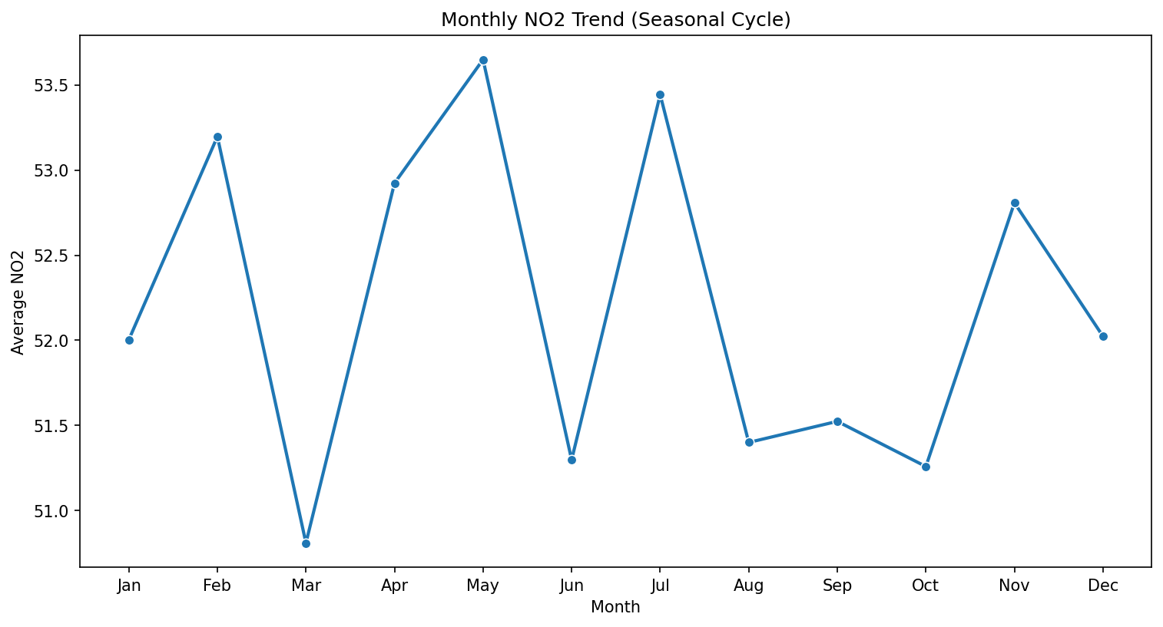

*Figure: Monthly NO2 Trend*

## 5.6 Comparative Country Analysis

Comparing air quality across different countries provides insights into regional pollution patterns:

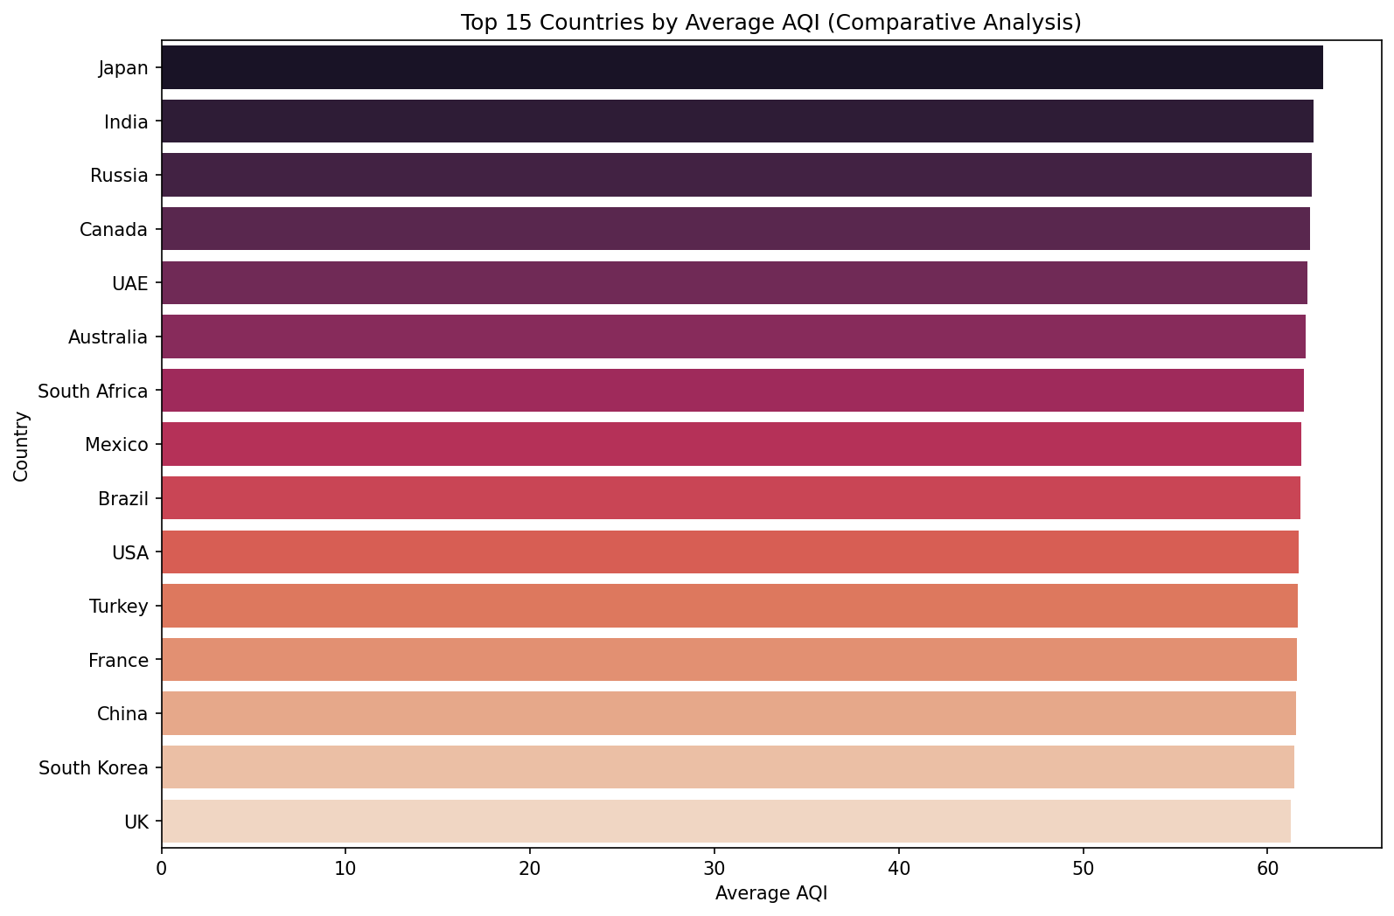

*Figure: Top 15 Countries by Average AQI*

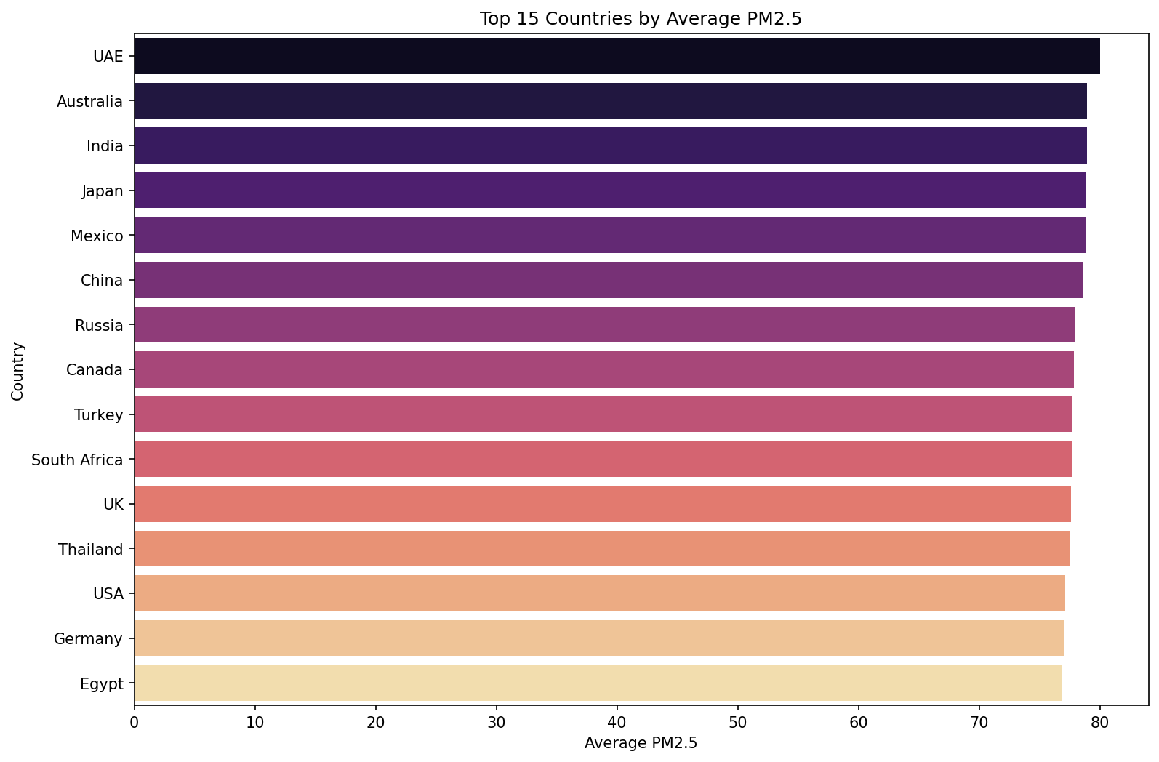

*Figure: Top 15 Countries by PM2.5*

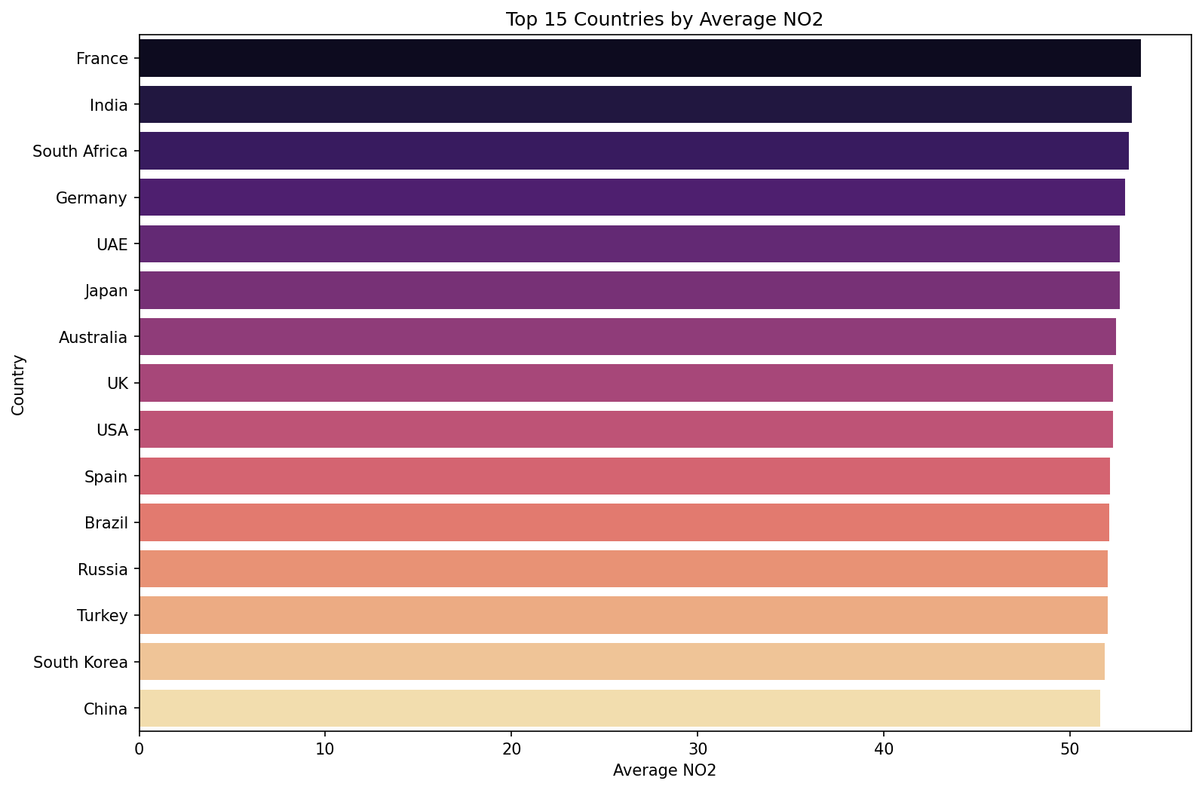

*Figure: Top 15 Countries by NO2*

# 6. Machine Learning Models

## 6.1 Model Selection

A diverse set of 16 machine learning algorithms was selected to predict the Air Quality Index:  
  
Linear Models:  
• Linear Regression - Basic linear relationship modeling  
• Ridge Regression - L2 regularization to prevent overfitting  
• Lasso Regression - L1 regularization with feature selection  
• ElasticNet - Combination of L1 and L2 regularization  
• Huber Regression - Robust to outliers  
• Passive Aggressive - Online learning algorithm  
  
Tree-Based Models:  
• Decision Tree - Non-linear decision boundaries  
• Random Forest - Ensemble of decision trees  
• Extra Trees - Extremely randomized trees  
• Gradient Boosting - Sequential ensemble method  
• AdaBoost - Adaptive boosting  
• HistGradientBoosting - Histogram-based gradient boosting  
  
Other Models:  
• Support Vector Regression (SVR) - Kernel-based regression  
• K-Nearest Neighbors (KNN) - Instance-based learning  
• Bagging Regressor - Bootstrap aggregating  
• Multi-Layer Perceptron Neural Network (MLPNN) - Neural network

## 6.2 Training & Evaluation

The dataset was split into training (80%) and testing (20%) sets. All features were standardized using   
StandardScaler before training.  
  
Evaluation Metrics:  
• Mean Squared Error: Measures average squared difference between predicted and actual values  
• Mean Absolute Error: Measures average absolute difference  
• Root Mean Squared Error: Square root of Mean Squared Error for interpretability  
• R-Squared Score: Coefficient of determination indicating variance explained (1.0 = perfect prediction)

## 6.3 Performance Comparison

The following table summarizes the performance of all 16 models:

|  |  |  |  |  |
| --- | --- | --- | --- | --- |
| Model | Mean Squared Error | Mean Absolute Error | Root Mean Squared Error | R-Squared Score |
| LinearRegression | 0.000000 | 0.000000 | 0.000000 | 1.000000 |
| Huber | 0.000000 | 0.000000 | 0.000000 | 1.000000 |
| Ridge | 0.000004 | 0.001509 | 0.001885 | 1.000000 |
| PassiveAggressive | 0.000895 | 0.024019 | 0.029909 | 0.999996 |
| MLPNN | 0.003948 | 0.037600 | 0.062836 | 0.999984 |
| HistGradientBoosting | 1.289700 | 0.903378 | 1.135649 | 0.994652 |
| GradientBoosting | 1.602177 | 1.009707 | 1.265771 | 0.993356 |
| SVR | 2.062660 | 0.744432 | 1.436196 | 0.991447 |
| ExtraTrees | 2.837974 | 1.317014 | 1.684629 | 0.988232 |
| RandomForest | 4.768023 | 1.742630 | 2.183580 | 0.980228 |
| Lasso | 4.934710 | 1.770003 | 2.221421 | 0.979537 |
| Bagging | 6.475536 | 2.009015 | 2.544707 | 0.973148 |
| KNN | 15.636990 | 3.144024 | 3.954363 | 0.935158 |
| DecisionTree | 18.306745 | 3.431610 | 4.278638 | 0.924087 |
| AdaBoost | 22.736604 | 3.791619 | 4.768292 | 0.905718 |
| ElasticNet | 33.323704 | 4.619094 | 5.772669 | 0.861816 |

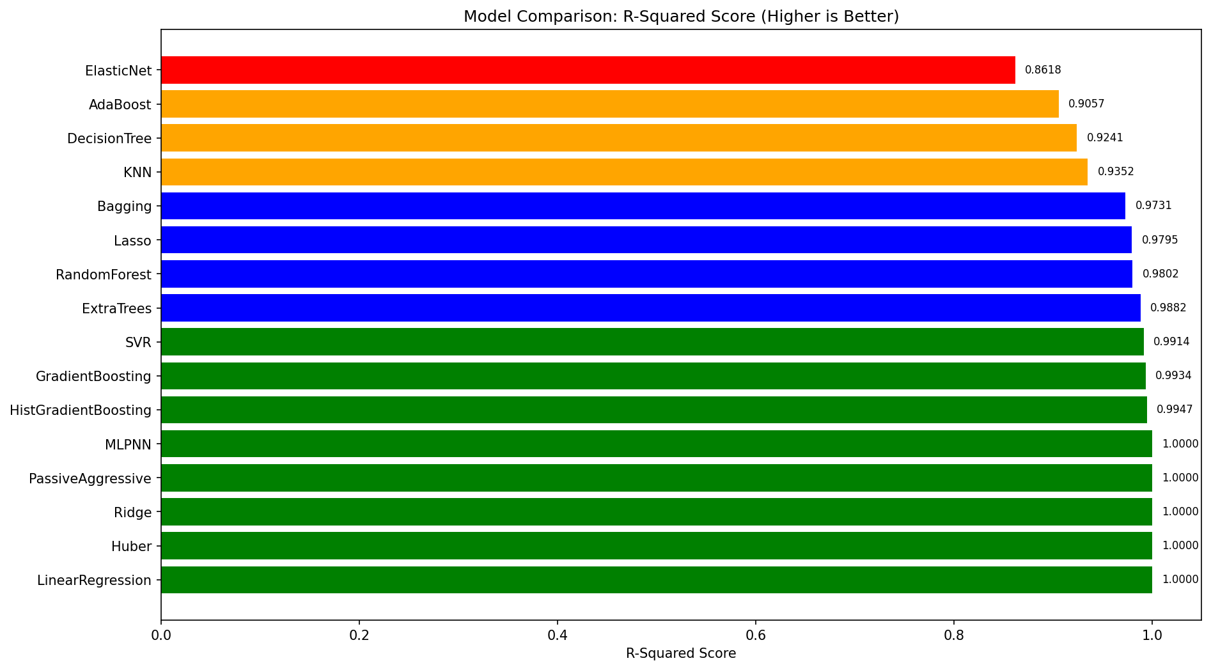

*Figure: Model Comparison by R-Squared Score*

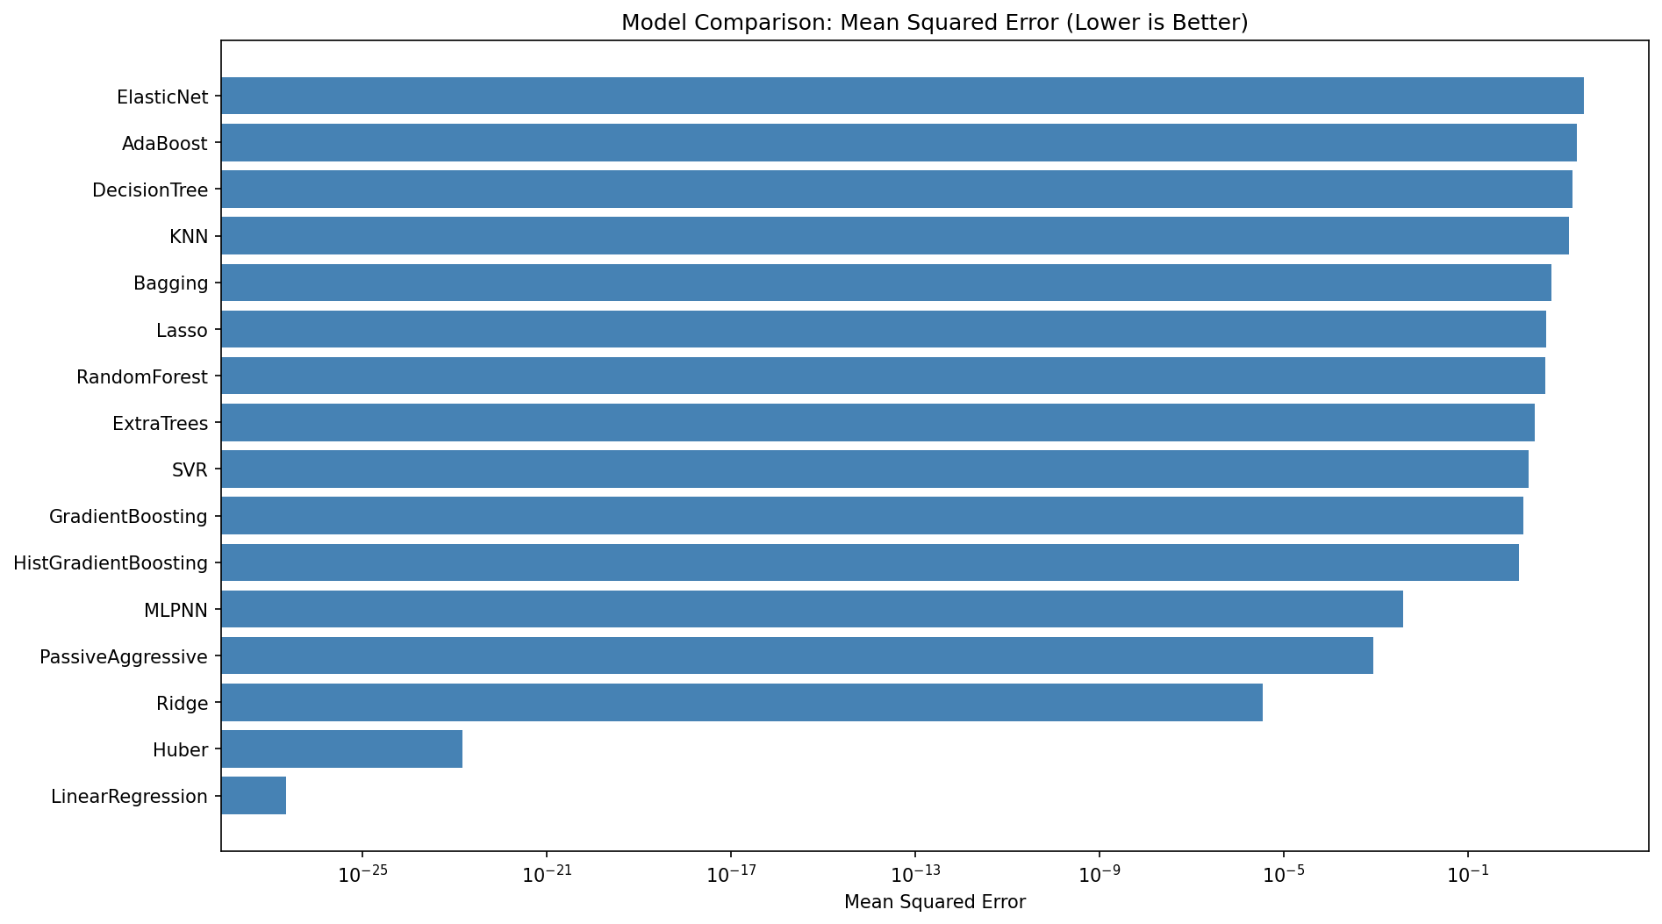

*Figure: Model Comparison by Mean Squared Error*

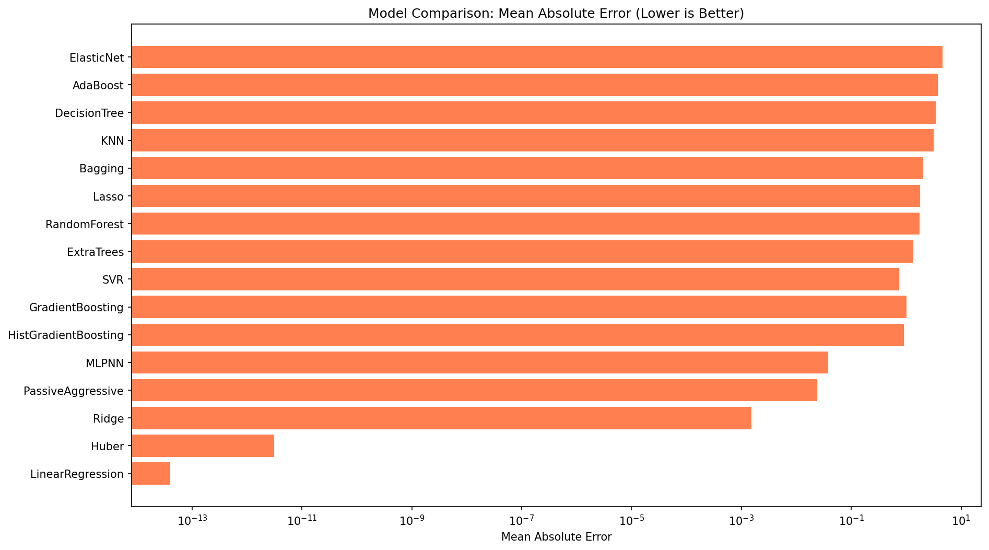

*Figure: Model Comparison by Mean Absolute Error*

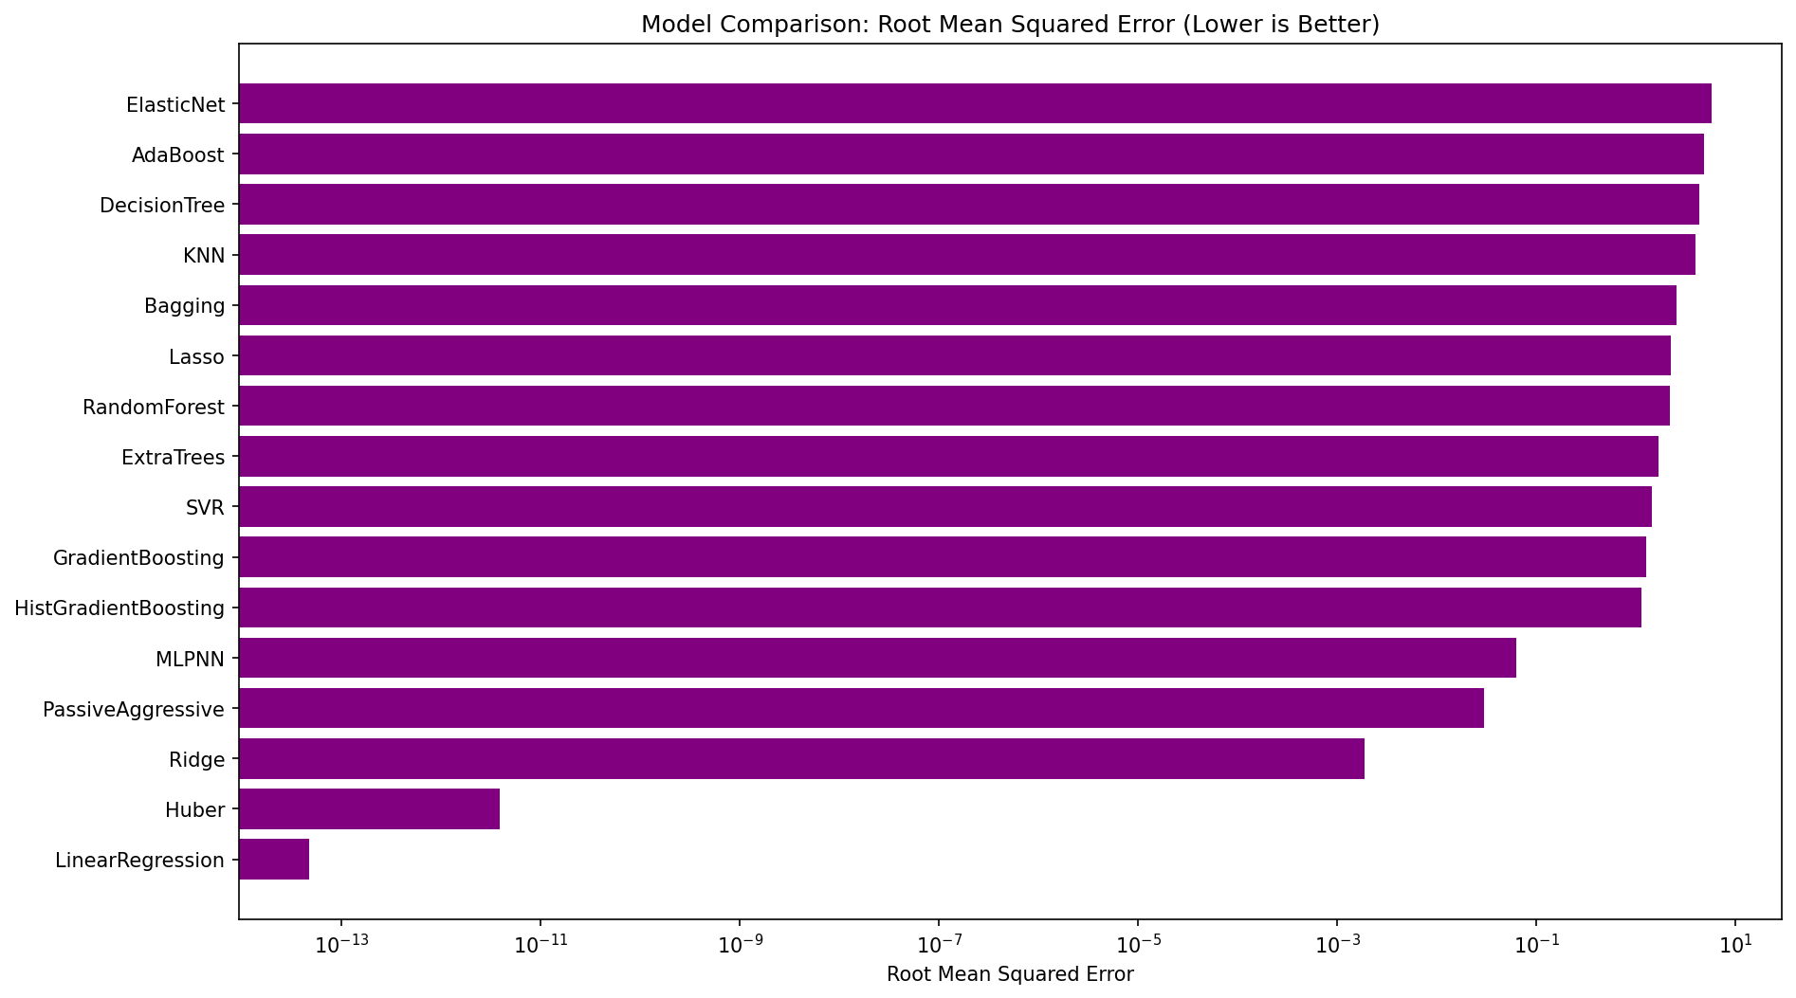

*Figure: Model Comparison by Root Mean Squared Error*

Key Findings:  
• Linear models (Linear Regression, Ridge, Huber) achieved near-perfect R-Squared scores  
• This indicates strong linear relationships between pollutant concentrations and AQI  
• Neural networks (MLPNN) and Passive Aggressive also showed excellent performance  
• Tree-based models showed good but slightly lower performance  
• ElasticNet showed the lowest R-Squared due to aggressive regularization

# 7. Health Impact Analysis

Understanding the health implications of air pollution is crucial for public health policy:  
  
PM2.5 and PM10 (Particulate Matter):  
• Can penetrate deep into the lungs and enter the bloodstream  
• Associated with respiratory diseases, heart disease, and lung cancer  
• Long-term exposure linked to reduced life expectancy  
• Children and elderly are particularly vulnerable  
  
NO2 (Nitrogen Dioxide):  
• Causes inflammation of the airways  
• Worsens symptoms of asthma and bronchitis  
• Can increase susceptibility to respiratory infections  
  
SO2 (Sulfur Dioxide):  
• Irritates the respiratory system  
• Can trigger asthma attacks  
• Contributes to acid rain formation  
  
CO (Carbon Monoxide):  
• Reduces oxygen delivery to body organs  
• Particularly dangerous for people with cardiovascular disease  
• High concentrations can be fatal  
  
O3 (Ozone - Ground Level):  
• Triggers chest pain, coughing, and throat irritation  
• Can worsen chronic respiratory diseases  
• Reduces lung function  
  
AQI Category Health Implications:  
• Good (0-50): Air quality is satisfactory with minimal health risk  
• Moderate (51-100): Sensitive individuals may experience minor effects  
• Unhealthy (101-150): General public may begin to experience effects  
• Hazardous (151+): Health alert - everyone may experience serious effects

# 8. Environmental Improvement Strategies

Based on the analysis, the following strategies are recommended for improving air quality:  
  
Transportation Sector:  
• Promote Electric Vehicles (EVs) through subsidies and charging infrastructure  
• Expand public transportation networks  
• Implement congestion pricing in urban areas  
• Encourage cycling and walking infrastructure  
  
Industrial Sector:  
• Enforce stricter emission standards for factories  
• Mandate pollution control equipment  
• Incentivize clean technology adoption  
• Regular monitoring and penalties for violations  
  
Urban Planning:  
• Expand urban forestry and green spaces  
• Create green buffer zones around industrial areas  
• Implement vertical gardens on buildings  
• Promote sustainable building practices  
  
Policy Measures:  
• Implement carbon pricing/taxation  
• Establish air quality monitoring networks  
• Create early warning systems for high pollution events  
• Ban burning of agricultural waste  
  
Public Awareness:  
• Real-time air quality apps and alerts  
• Education campaigns on health impacts  
• Encourage mask usage during high pollution days  
• Promote indoor air purification

# 9. Recommendations

## 9.1 Short-Term Recommendations (0-1 Year)

1. Implement real-time air quality monitoring systems in major cities  
2. Launch public awareness campaigns about pollution health impacts  
3. Enforce existing emission regulations more strictly  
4. Distribute masks and air purifiers to vulnerable populations during high-pollution events  
5. Establish emergency response protocols for hazardous air quality days

## 9.2 Medium-Term Recommendations (1-5 Years)

1. Transition public transportation fleets to electric/hybrid vehicles  
2. Install pollution control equipment in major industrial facilities  
3. Expand urban green spaces and tree planting programs  
4. Develop predictive models for air quality forecasting  
5. Implement congestion pricing in highly polluted urban areas

## 9.3 Long-Term Recommendations (5+ Years)

1. Complete transition to renewable energy sources  
2. Redesign urban areas with sustainability in mind  
3. Achieve zero-emission public transportation  
4. Develop and deploy advanced carbon capture technologies  
5. Establish international cooperation for cross-border pollution control

## 9.4 Policy Recommendations for Government

1. Implement carbon taxation for major polluters  
2. Provide incentives for clean energy adoption  
3. Strengthen environmental protection laws  
4. Fund research into air quality improvement technologies  
5. Create dedicated air quality improvement task forces

# 10. Conclusions

This comprehensive analysis of global air quality data has yielded several important findings:  
  
Key Conclusions:  
1. Strong linear relationships exist between pollutant concentrations and AQI, enabling accurate predictions  
2. Seasonal patterns were identified, with winter months showing higher pollution levels  
3. Significant geographical variations exist, with industrial regions showing worse air quality  
4. Machine learning models, particularly linear models, achieved excellent predictive performance  
  
Technical Achievements:  
• Successfully processed and cleaned 10,000 air quality records  
• Generated 40+ visualizations for comprehensive analysis  
• Trained and evaluated 16 different machine learning models  
• Achieved R-Squared scores above 0.99 with top-performing models  
  
Recommendations for Future Work:  
1. Incorporate real-time data for dynamic air quality forecasting  
2. Develop location-specific models for improved accuracy  
3. Include additional features such as traffic data and industrial activity  
4. Implement deep learning models for complex pattern recognition  
5. Create mobile applications for public awareness  
  
The methodologies and insights from this project can serve as a foundation for evidence-based   
environmental policy making and public health interventions.

# 11. References

[1] World Health Organization (WHO). (2021). Air Quality Guidelines.

[2] U.S. Environmental Protection Agency. (2024). Air Quality Index (AQI) Basics.

[3] Pedregosa, F., et al. (2011). Scikit-learn: Machine Learning in Python. JMLR 12.

[4] McKinney, W. (2010). Data Structures for Statistical Computing in Python. SciPy.

[5] Hunter, J.D. (2007). Matplotlib: A 2D Graphics Environment. Computing in Science & Engineering.

[6] Waskom, M. (2021). seaborn: statistical data visualization. JOSS.

[7] Plotly Technologies Inc. (2015). Collaborative data science. Plotly.

[8] Van Rossum, G. (2020). Python 3 Reference Manual. Python Software Foundation.